Tri-Op 7: Film Studies
History of Film: Notes from PowerPoint
Plays, dances, theatre:
-preceded film by 1000s of years
-elements common to film:
-sets, scripts, costumes, producers, storyboards, directors, scores, actors, audiences

1600’s- Camera obscura creates a moving image, but it is not preserved in a recording; one of the inventions leading to photography


1800’s- Persistence of vision-Bird and cage demo
- 1860’s Zoetrope-illusion of action from a rapid succession of static pictures (anything static-not moving- that is presented to the eye over 10 frames per second our brain may interpret as moving)
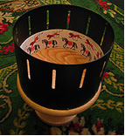

- 1877-Praxinoscope-successor of the zoetrope, brighter and less distorted picture because it used mirrors instead of slits (look at it from the top)

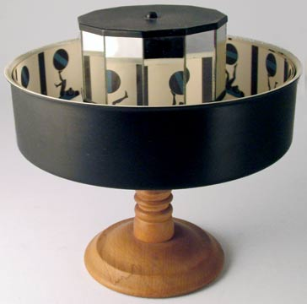
- 1894-Mutoscope- worked with the same principle as a flip book but it is on a rolodex. A reel held 850 flexible, opaque cards (7cm x 4.75 cm). It was coin operated with a hand crank and a light behind the cards to illuminate.
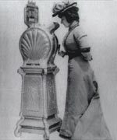

1880-The motion picture camera -The movie camera is a type of photographic camera which takes a rapid sequence of photographs on strips of film (celluloid film if you want to do some research). They were used with a projector which shined light through the processed and printed film. Silent films

  - -Known as the “Age of the Silver Screen”
1) Silent films
2) Intertitles used to narrate
3) Live music-contributes to atmosphere and gives emotional cues, single piano to large orchestras; by 1920 films came with a prepared list of sheet music to be played with the film
1920’s –Talkies and the “Golden Age” of film
- Talking pictures came into being; were also known as “talkies”
- There was a soundtrack of speech, music and sound effects synchronized with the action on the screen
- The first full length feature was 1927’s The Jazz Singer

The Golden Age-1920’s-1960
1) There were the Big Five studios- These studios used to own the theatres (until 1948-more on this later)
1. MGM
2. Paramount
3. RKO
4. Warner Brothers
5. 20th Century Fox

2) There were also studios known as The Minor 3:
1. Universal
2. Columbia
3. United Artists

3) There were independents as well:
Ex: Walt Disney
4) Most films during this time adhered closely to a formula (genre)
These genres were predictable and allowed for studios to reuse scripts, formulas, actors, sets, and costumes
Due to this economical way of producing movies, each studio became known for certain genres:
WB-gangster Columbia-western
MGM-musicals, melodramas Universal-horror
RKO-literary adaptations

5) During the Golden Age the main genres were:
Westerns
Comedies
Crime/detective stories
Melodrama
Horror
Musicals
Romance

What about genres now?? Indefinable-too many, too mixed usually

For movies in the golden age go to http://www.hollywoodsgoldenage.com/

6) In 1948 the Supreme Court ruling that the major studios could not own their own theatres-the independents wanted this!!
This decision undid the studio system and removed the cornerstone of predictability of the previously listed genres
Without control of the distribution network (theatres) to ensure profits, the studio system declined and the Golden Age slowly came to an end

7) Genres became less formulaic
From the original 7 genres came:
1. Hybrids-two originals combined
Ex: romantic comedies
Ex: musical horrors

2. Subgenres
Ex: spaghetti westerns (westerns produced in Italy)
Ex: slapstick comedy (physical humour/stunts)

8) A few more original genres emerged during this period:
1. Film noir- typically have shadowy characters and violent crimes which reflected the cultural stresses and instability that followed WWII
- whole idea “drenched in darkness”
-plot not important –all about feeling

There is also now a subgenre of film noir:
Tech Noir
Ex: Blade Runner, Terminator, Minority Report
As well as a new genre:
Film Soleil –where all revelations are made in the light of day

2. Blaxploitation -A film genre which emerged in the United States circa 1971.
-Were made specifically for an urban, black audience.
-When set in the Northeast or West Coast, films typically take place in ghettos and
feature plotlines which entail crime, hit men, drug dealers and pimps.
-Antagonistic white characters such as corrupt cops, politicians, prostitutes and gullible
gangsters are common.
-Films set in the South often take place on a plantation, dealing with slavery and
miscegenation.

1970-present- New Hollywood
This is the first time that film-school educated directors have come onto the scene drawing on established genres, special effects and large advertising budgets
In addition to New Hollywood, this time frame has seen two other new aspects to film:
1. Sequels-Terminator, Harry Potter, Lord of the Rings, Rocky, The Hangover, Scary
Movie, Saw, Land Before Time…take your pick, there are hundreds!
2. Global Genres-filming in other countries and large fan bases in other countries,
characters that people from around the world can relate to

